Chapter 6, Solution 69.

RC = 4 x 10⁶ x 1 x 10⁻⁶ = 4

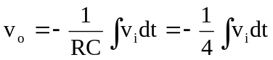
For 0 < t < 1, v_{i} = 20, 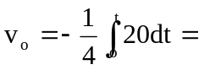-5t mV

For 1 < t < 2, v_{i} = 10, 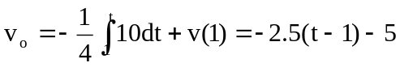
= -2.5t - 2.5mV

For 2 < t < 4, v_{i} = - 20, 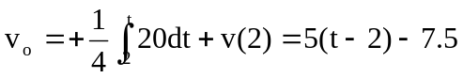
= 5t - 17.5 mV

For 4 < t < 5m, v_{i} = -10, 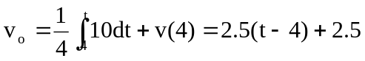
= 2.5t - 7.5 mV

For 5 < t < 6, v_{i} = 20, 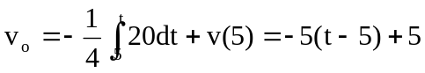
= - 5t + 30 mV

Thus v_{o}(t) is as shown below:
v(t) (V)
-5
2
3
4
1
5
7
5
t (s)
6
-7.5
-2.5
0
2.5

